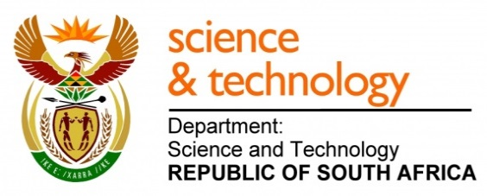
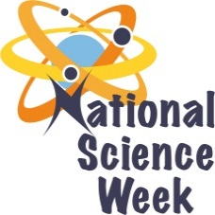
NATIONAL SCIENCE WEEK 2017

ORGANISATION NAME: |  |  |  | >University of the Witwatersrand
CONNECT WITH US ONLINE |  |  | Twitter: |  | >
 |  |  | Facebook: |  | >
 |  |  | Website: |  | >
DATE OF ACTIVITY | DISTRICT WHERE ACTIVITY BEING HELD | VENUE WHERE ACTIVITY IS TAKING PLACE | ACTIVITIES  (Provide a short description of the activity) |  |  | TARGET AUDIENCE | TIMESLOT | CONTACT PERSON  EMAIL ADDRESS  PHONE NUMBER | BOOKING REQUIRED  (YES OR NO)
7 – 11 Aug | Gauteng Central | Wits | Tour of the Wits Science and Engineering Faculties: laboratories, museums and demonstrations |  |  | School learners, teachers and students | 9:00 – 10:30 | Cheryl Dehning  0113161426  0833761734  Cheryl Dehning <cheryl@innercs.com> | Yes
7-11 Aug | Gauteng Central | Wits Theatre | Wits Science Slam. Postgraduate students present their research to learners and students in a 10 minute fun way. The audience votes for the best presentation. At the end of the week we have finals and a winner is selected |  |  | School learners teachers and students | 11:00-12:30 | Ian McKay  0117176667  0845003902  Ian.mckay@wits.ac.za | Yes
7 Aug | Gauteng Central | Wits | Wits students and staff are given information leaflets about Wits National Science Week and invited to participate in our online science survey and competition |  |  | Students and Staff | 07:00- 11:00 | Amanda Mudau  Caimiz Mudau  0117176665 <mmamandaskye@gmail.com> | No
7- 21 Aug | Online | Online | Online Science Week Social Media Campaign, science survey and competition |  |  | Students and Staff | Online | Ian Mckay  <ian.mckay@wits.ac.za>  Maria Kombrink  <maria.meraai@gmail.com> | No

