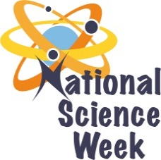
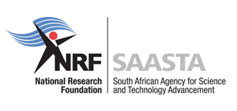
NATIONAL SCIENCE WEEK 2017

ORGANISATION NAME: |  |  |  | >Vuwani Science Resource Centre
CONNECT WITH US ONLINE |  |  | Twitter: |  | >
 |  |  | Facebook: |  | > VUWANI SCIENCE RESOURCE CENTRE
 |  |  | Website: |  | >
DATE OF ACTIVITY | DISTRICT WHERE ACTIVITY BEING HELD | VENUE WHERE ACTIVITY IS TAKING PLACE | ACTIVITIES  (Provide a short description of the activity) |  |  | TARGET AUDIENCE | TIMESLOT | CONTACT PERSON  EMAIL ADDRESS  PHONE NUMBER | BOOKING REQUIRED  (YES OR NO)
 | Vhembe | VUWANI SCIENCE RESOURCE CENTRE | - Advancing Science Tourism by moving around the science centre and observing the different renewable activities  - Fun with weather parameter measurements and the use of Mathematical Modelling  - Viewing exhibits and guided tour |  |  | Public, Learners and scientists | 08h00- 15h30 | eric.maluta@univen.ac.za  0785172981/ | No
 | Vhembe | VUWANI SCIENCE RESOURCE CENTRE | - Wonders of Biotechnology Lectures, demonstration and Viewing exhibits  - Renewable energy: Viewing exhibits and guided tour  - IKS: Viewing exhibits and guided tour |  |  | Public, Learners and scientists | 08h00- 15h30 | eric.maluta@univen.ac.za  0785172981/ | No
 | Vhembe | VENDA PLAZA/ UNIVERSITY OF VENDA MAIN GATE | - Viewing exhibits  - Renewable energy exhibits |  |  | Public, Learners and scientists | 08h00- 15h30 | eric.maluta@univen.ac.za  0785172981/ | No
 | Vhembe | THENGWE SECONDARY SCHOOL | - Motivational talk  - Viewing exhibits  - Renewable energy exhibits |  |  | Public, Learners and Teachers | 08h00- 15h30 | eric.maluta@univen.ac.za  0785172981/ | No
 | Vhembe | NGWENI SECONDARY SCHOOL | - Motivational talk  - Viewing exhibits  - Renewable energy exhibits |  |  | Public, Learners and Teachers | 08h00- 15h30 | eric.maluta@univen.ac.za  0785172981/ | No

