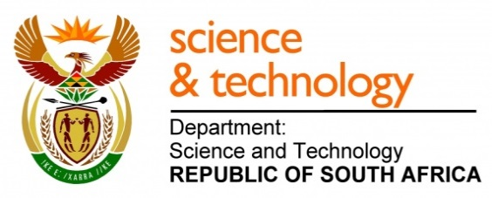
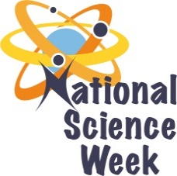
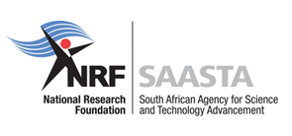
NATIONAL SCIENCE WEEK 2017

ORGANISATION NAME: |  |  |  | - Vimo Industrial Services
CONNECT WITH US ONLINE |  |  | Twitter: |  | >
 |  |  | Facebook: |  | >
 |  |  | Website: |  | >
DATE OF ACTIVITY | DISTRICT WHERE ACTIVITY BEING HELD | VENUE WHERE ACTIVITY IS TAKING PLACE | ACTIVITIES  (Provide a short description of the activity) |  |  | TARGET AUDIENCE | TIMESLOT | CONTACT PERSON  EMAIL ADDRESS  PHONE NUMBER | BOOKING REQUIRED  (YES OR NO)
7th August 2017 | Nkangala | Marapyane | Maths & Science Quiz for selection of learners who will be attending a tour at the Museum. |  |  | Learners | 10:00 – 12:00 | N/A | No
8th August 2017 | Nkangala | Marapyane | Maths & Science Quiz for selection of learners who will be attending a tour at the Museum. |  |  | Learners | 10:00 – 12:00 | N/A | No
9th August 2017 |  | Hammanskraal | The science fair will be held to promote science related careers.  To give members of the public to engage in science experiments to enhance knowledge and see that science is part of their everyday life. |  |  | Public | 10:00 – 12:00 | Zondi Mahlangu  012 727 1241  zondi@mseed.co.za | Yes
10th August 2017 | Tshwane | Pretoria | A day tour at the museum with Primary school learners |  |  | Learners | 10:00 – 12:00 | Mpumelelo Ngcaku  012 336 4020  mpumelelo@freedompark.co.za | Yes
11th August 2017 | Tshwane | Pretoria | A day tour at the Museum with High School learners |  |  | Learners | 10:00 – 12:00 | Grace Masango  012 734 0260  cullinantour@mweb.co.za | Yes

