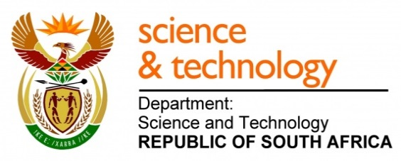
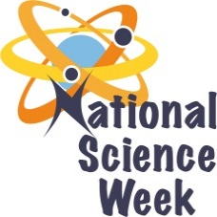
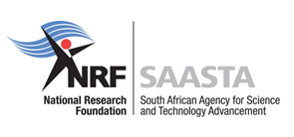
NATIONAL SCIENCE WEEK 2017

ORGANISATION NAME: |  |  |  | >Unizulu Science Centre
CONNECT WITH US ONLINE |  |  | Twitter: |  | >
 |  |  | Facebook: |  | > Unizulu Science Centre
 |  |  | Website: |  | > www.unizulusc.org
DATE OF ACTIVITY | DISTRICT WHERE ACTIVITY BEING HELD | VENUE WHERE ACTIVITY IS TAKING PLACE | ACTIVITIES  (Provide a short description of the activity) |  |  | TARGET AUDIENCE | TIMESLOT | CONTACT PERSON  EMAIL ADDRESS  PHONE NUMBER | BOOKING REQUIRED  (YES OR NO)
7th, 8th, 10th, 11th Aug | King Cetshwayo | Unizulu Science Centre | Various exciting activities at our science centre which include tourism in KZN, mathematics activities, light and colour, chemistry and astronomy shows, games, exhibitions and many more |  |  | Primary and secondary schools | 9:00 – 13:00 or  13:00 – 16:00 | Silindile Mthembu (for all activities) | YES
Sat 12th August | King Cetshwayo | Unizulu Science Centre | Various exciting activities at our science centre which include tourism in KZN, mathematics activities, light and colour, chemistry and astronomy shows, games, exhibitions and many more |  |  | General Public | 9:00 – 14:00 | silindilemthembu1@gmail.com | NO
Tues 8th August | iLembe | Stanger High School (TBC) | Joining with the Moses Kotane Institute to provide a community day focussing on science, technology and careers with various activities that will include mathematics activities, women in science, astronomy shows, games, exhibitions and many more |  |  | General Public from the local community | 9:00 – 14:00  (TBC) | 035-7973204 | NO

