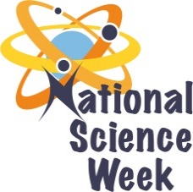
NATIONAL SCIENCE WEEK 2017

ORGANISATION NAME: |  |  |  | - University of johannesburg
CONNECT WITH US ONLINE |  |  | Twitter: |  | >
 |  |  | Facebook: |  | >
 |  |  | Website: |  | >
DATE OF ACTIVITY | DISTRICT WHERE ACTIVITY BEING HELD | VENUE WHERE ACTIVITY IS TAKING PLACE | ACTIVITIES  (Provide a short description of the activity) |  |  | TARGET AUDIENCE | TIMESLOT | CONTACT PERSON  EMAIL ADDRESS  PHONE NUMBER | BOOKING REQUIRED  (YES OR NO)
07 -11 | Soweto | UJ Soweto Campus  Imbizo Hall | ‘Chemistry is Fun.’  The show consists of various interesting chemical reactions that will be demonstrated and explained to the learners.  The show is approximately 40 minutes long, so we are willing to do 2 to 3 consecutive shows between 13:00 and 15:00. We would suggest that the group of learners attending the show should be between 30 to 40 learners, so that it is not too crowded and they can easily see the demonstration. |  |  | 8-12 | 8am -15pm | sweetnessm@uj.ac.za  011 559 5754  071 907 3860 | No
7-11 |  |  | 20 hours of Maths Games and offer two 30 minute talks |  |  | 8-12 | 8am – 15pm | sweetnessm@uj.ac.za  011 559 5754  071 907 3860 | No
 |  |  | There will be two games that the students can play and a display of items from the courses they can do in our department. We will also have a microscope the students can look through. |  |  | 4-6 | 8am – 15pm | sweetnessm@uj.ac.za  011 559 5754  071 907 3860 | No

