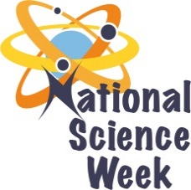
NATIONAL SCIENCE WEEK 2017

ORGANISATION NAME: |  |  |  | - Science Spaza – Jive Media Africa
CONNECT WITH US ONLINE |  |  | Twitter: |  | > @sciencespaza
 |  |  | Facebook: |  | - Sciencespaza
 |  |  | Website: |  | - Sciencespaza.org.za
DATE OF ACTIVITY | DISTRICT WHERE ACTIVITY BEING HELD | VENUE WHERE ACTIVITY IS TAKING PLACE | ACTIVITIES  (Provide a short description of the activity) |  |  | TARGET AUDIENCE | TIMESLOT | CONTACT PERSON  EMAIL ADDRESS  PHONE NUMBER | BOOKING REQUIRED  (YES OR NO)
29 June 2017 | umgungundlovu | Zibekuzulu High School | Hip Hop Science Spaza |  |  | Learners |  | Sthabile Mazubane  +27 (0)81 367 5996 | No.
5-12 Aug | Nationally | Television (Hectic Nine-9, SABC 2, 4pm) | Short films about Science and Rocks in Tourism Locations  Short films about young people creating hip hop songs about science and rocks in tourism locations |  |  | Youth | 4pm – 5pm | Sthabile Mazubane  +27 (0)81 367 5996 | N/A
5-12 Aug | Nationally | Various community Radio Stations | Songs and interviews with scientists to be played on community radio |  |  | Public | Various | Sthabile Mazubane  +27 (0)81 367 5996 | N/A
01 Aug | Nationally | Science Clubs (see www.sciencespaza.org) | Activity worksheets and Spaza Space newsletter distributed to science clubs and science centres nationally |  |  | Public | Various | Marvie Khumalo +27(0) 33 342 9382 | N/A

