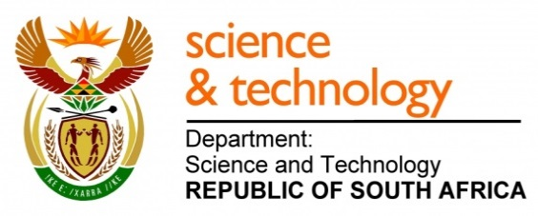
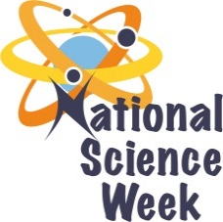
NATIONAL SCIENCE WEEK 2017

ORGANISATION NAME: |  |  |  | - SANSA Science Centre, Hermanus
CONNECT WITH US ONLINE |  |  | Twitter: |  | @SANSA7
 |  |  | Facebook: |  | > South African National Space Agency (SANSA)
 |  |  | Website: |  | - http://www.sansa.org.za
DATE OF ACTIVITY | DISTRICT WHERE ACTIVITY BEING HELD | VENUE WHERE ACTIVITY IS TAKING PLACE | ACTIVITIES  (Provide a short description of the activity) |  |  | TARGET AUDIENCE | TIMESLOT | CONTACT PERSON  EMAIL ADDRESS  PHONE NUMBER | BOOKING REQUIRED  (YES OR NO)
7 August 2017 | Overberg | SANSA ,  Hermanus | A tour of Space Weather at the Space Agency. SANSA Hermanus is the Regional Warning Centre for space weather in Africa. Learners will be provided with the opportunity to engage with space weather scientists. This space weather tour includes observing detailed, near real time satellite images of the sun and exposure on how mathematics is used to analyse data from space weather satellites and science instruments at the facility. |  |  | Grade 4-11 | 9:00 – 10:30  11:00 – 12:30 | Elisa Fraser  efraser@sansa.org.za  028 312 1196 | Yes
8 August 2017 | Overberg | SANSA, Hermanus | A tour of Space Weather at the Space Agency. SANSA Hermanus is the Regional Warning Centre for Space Weather in Africa. Learners will be provided with the opportunity to engage with space weather scientists. This space weather tour includes observing detailed, near real time satellite images of the sun and exposure on how mathematics is used to analyse data from space weather satellites and science instruments at the facility. |  |  | Grade 4-11 | 9:00 – 10:30  11:00 – 12:30 | Elisa Fraser  efraser@sansa.org.za  028 312 1196 | Yes
10 August 2017 – 11 August 2017 | Central Karoo | Various schools in Central Karoo | SANSA Space Lab tour to Central Karoo. The SANSA Space Lab will travel to schools and make learners aware of SANSA and its role in space science at a national and international level. Learners will be engaging with a mathematics activity on space weather. SANSA career information will also be shared. |  |  | Grade 10-12 | 9:00 – 12:00 | Thandile Vuntu  tvuntu@sansa.org.za  028 312 1196 | Yes
10 August 2017 – 11 August 2017 | Overberg | SANSA, Hermanus | SANSA Tour de Space. Learners will be exposed to career possibilities at the Space Agency. The Tour de Space includes a visit to the SANSA interactive Science Centre. SANSA Science Club learners will showcase their projects. |  |  | Grade 7 -11 | 9:00 – 10:30  11:00 – 12:30 | Elisa Fraser  efraser@sansa.org.za  028 312 1196 | Yes
12 August 2017 | Overberg | SANSA Hermanus | An Open Day at SANSA Space Science Hermanus where the space agency’s role in national and international research and technology activities will be highlighted. The role of the SANSA Space weather centre on monitoring the space into which satellites are launched as part of ensuring a sustainable planet will be the main focus. SANSA as an entity of the DST and its operation at a national level and engagement with international space related entities and agencies will be showcased to the public. |  |  | Public | 10:00 – 14:00 | Elisa Fraser  efraser@sansa.org.za  028 312 1196 | Yes

