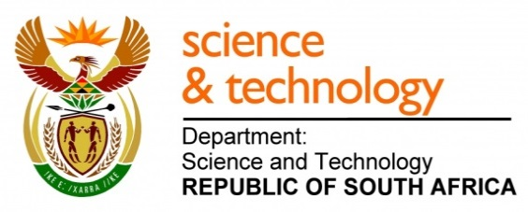
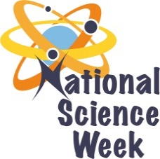
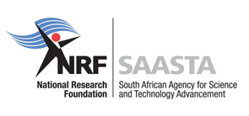
NATIONAL SCIENCE WEEK 2017

ORGANISATION NAME: |  |  |  | >RHODES UNIVERSITY
CONNECT WITH US ONLINE |  |  | Twitter: |  | >@Rhodes_Uni
 |  |  | Facebook: |  | > https://www.facebook.com/rhodesuniversity/
 |  |  | Website: |  | > http://www.ru.ac.za/
DATE OF ACTIVITY | DISTRICT WHERE ACTIVITY BEING HELD | VENUE WHERE ACTIVITY IS TAKING PLACE | ACTIVITIES  (Provide a short description of the activity) |  |  | TARGET AUDIENCE | TIMESLOT | CONTACT PERSON  EMAIL ADDRESS  PHONE NUMBER | BOOKING REQUIRED  (YES OR NO)
5 August 2017 | Sarah Baartman District | Rhodes University, Grahamstown | RU Faculties of Science and Pharmacy Open Day  - During this day, Saturday morning from 09h00 – 13h00, various Departments will hold activities aimed at grade 9 learners their parents/guardians and teachers. These activities will range from career talks, hands-on experiments, demonstrations, lectures on the various subjects, depending on what the Department’s staff and students have to offer.  - The aim will be to convince learners how important it is to choose maths, Physical Sciences and Life Sciences for subjects to take to grade 12 and get them excited about Science as a possible career choice. |  |  | We are targeting 350 Grade 9 learners to join us with around 50 educators and 50 of our local general public. | We will open registration at 8am and things will end at 1pm | Kim Weaver k.weaver@ru.ac.za 0466037702 | YES
4-11 August 2017 | Sarah Baartman District | Grahamstown | Grocotts Mail, a local newspaper along with two local community radio stations will showcase the Rhodes University Faculties of Science and Pharmacy by interviewing key scientists in the Institution. The focus will be showcasing the incredible scientists and research facilities we have on our doorstep here in Grahamstown. ‘Science in Grahamstown’ will be focussed around our scientists and research facilities and will be a fun and lively cross-media hyper-local education and awareness campaign.  Focus areas will be the novel research facilities on Rhodes University’s campus as well as the Albany Museum as places to visit during the NSW RU Open Day. |  |  | The newspaper and radio stations reach around 2500 people of our general public. 50 students, 10 journalists and 20 scientists will be involved in these activities. | The radio broadcasts will be the whole week (3-5 shows) and the Grocotts will have pages about NSW and ‘Science in Grahsmtown’ in the paper on Friday the 4th of August and the 11th of August. | Sue Maclennan – Editor Grocott’s Mail: ed5@ed.grocotts.co.zav  AND  Kim Weaver k.weaver@ru.ac.za 0466037702 | NO

