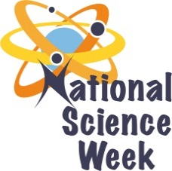
NATIONAL SCIENCE WEEK 2017

ORGANISATION NAME: |  |  |  | - Phiemma Trading PTY LTD
CONNECT WITH US ONLINE |  |  | Twitter: |  | >
 |  |  | Facebook: |  | >
 |  |  | Website: |  | >
DATE OF ACTIVITY | DISTRICT WHERE ACTIVITY BEING HELD | VENUE WHERE ACTIVITY IS TAKING PLACE | ACTIVITIES  (Provide a short description of the activity) |  |  | TARGET AUDIENCE | TIMESLOT | CONTACT PERSON  EMAIL ADDRESS  PHONE NUMBER | BOOKING REQUIRED  (YES OR NO)
07 Aug 17 | Ehlanzeni | Ngazi Ngozi Secondary  Malekutu Primary | Role models – Role models will be engaged with learners about their careers.  Maths Games – Learners will be doing some maths games and puzzles  Space Science presentation. |  |  | Primary and secondary school learners and educators | 08h00 to 14h00 | Ms. Portia Mgwenya  0720762002 | No.
08 Aug 17 | Ehlanzeni | Sifunindlela Primary  Zikode secondary | Role models – Role models will be engaged with learners about their careers.  Maths Games – Learners will be doing some maths games and puzzles  Space Science presentation. |  |  | Primary and secondary school learners and educators | 08h00 to 14h00 | Ms. Portia Mgwenya  0720762002
09 Aug 17 | Ehlanzeni | Kabokweni Complex | Role models – Role models will be engaged with participants about their careers.  Maths Games – Participants will be doing some maths games and puzzles  Space Science presentation. |  |  | Public | 08h00 to 14h00 | Ms. Portia Mgwenya  0720762002

