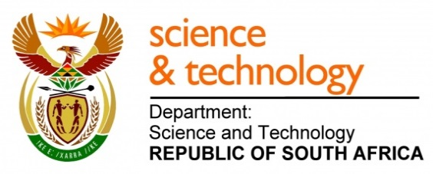
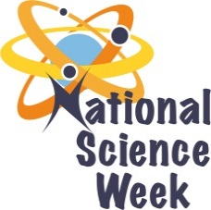
NATIONAL SCIENCE WEEK 2017

ORGANISATION NAME: |  |  |  | National Museum, Bloemfontein
CONNECT WITH US ONLINE |  |  | Twitter: |  | >
 |  |  | Facebook: |  | >https//:web.facebook.com/National-Museum-Bloemfontein-548352835278566/
 |  |  | Website: |  | >www.nasmus.co.za
DATE OF ACTIVITY | DISTRICT WHERE ACTIVITY BEING HELD | VENUE WHERE ACTIVITY IS TAKING PLACE | ACTIVITIES  (Provide a short description of the activity) |  |  | TARGET AUDIENCE | TIMESLOT | CONTACT PERSON  EMAIL ADDRESS  PHONE NUMBER | BOOKING REQUIRED  (YES OR NO)
7,8,10,11 Aug 2017 | Mangaung Metropolitan Municipality | National Museum, Bfn | “Behind the scenes scientific tour” Each visiting group is guided around the scientific laboratories where they getting familiar through demonstrations, scientific methods and expertise that go into the study and storage of specimens and the scientific significance thereof. |  |  | Targeted companies and different departments at CUT/UFS = 120 | 9:00 – 10:00  14:00 – 15:00 | A van Staden  ancilia@nasmus.co.za  051 4479609 | Yes
7,8,10,11 Aug 2017 | Mangaung Metropolitan Municipality | Vulamasango Sec school,  Kaelang Sec school,  Atang Int school,  Kagisho Comp school | “Mobile Museum outreach trips” During the presentations and exhibitions we will focus on the different ways and understanding of science in the everyday operation of our scientists and look at various careers that are available in sciences at the National Museum, Bfn. |  |  | Secondary schools = 770 | 9:00 – 10:00 | A van Staden  ancilia@nasmus.co.za  051 4479609 | Yes
5,7,8,10,11,12 Aug 2017 | Mangaung Metropolitan Municipality | Fichardtpark Public Library,  Trevor Barlow, Library | “Temporary exhibitions at local libraries” Through these exhibitions we will show equipment scientists in die various research departments at the National Museum use to do their jobs as well as interesting artefacts from various research departments. |  |  | General public visiting the libraries = 2500 | Whole day that the libraries are open | A van Staden  ancilia@nasmus.co.za  051 4479609 | No

