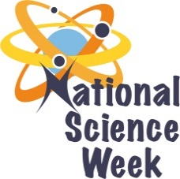
NATIONAL SCIENCE WEEK 2017

ORGANISATION NAME: |  |  |  | National Zoological Gardens (NZG)
CONNECT WITH US ONLINE |  |  | Twitter: |  | @natzoo
 |  |  | Facebook: |  | @NZGPretoria
 |  |  | Website: |  | www.nzg.ac.za
DATE OF ACTIVITY | DISTRICT WHERE ACTIVITY BEING HELD | VENUE WHERE ACTIVITY IS TAKING PLACE | ACTIVITIES  (Provide a short description of the activity) |  |  | TARGET AUDIENCE | TIMESLOT | CONTACT PERSON  EMAIL ADDRESS  PHONE NUMBER | BOOKING REQUIRED  (YES OR NO)
5, 6, 9, 12 & 13 August 2017 | Tshwane, Gauteng | NZG | Interactive displays for zoo visitors |  |  | Zoo visitors of all ages | 9h00 – 15h00 | Ulrich Oberprieler  Ulrich@nzg.ac.za  102 339 2743 | No
7, 8, 10 & 11 August 2017 | Tshwane, Gauteng | NZG | Interactive programme for Grade 10 learners |  |  | Grade 10 learners | 9h00 – 13h00 |  | Pre-booked only
7, 8,10 & 11 August 2017 | Waterberg, Limpopo | Mokopane Biodiversity Centre | Interactive programme for Grade 10 learners |  |  | Grade 10 learners | 9h00 – 13h00 |  | Pre-booked only

