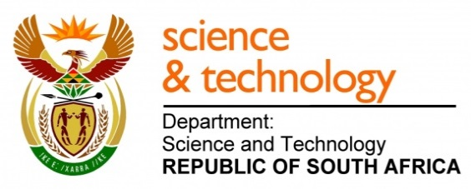
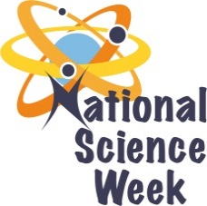
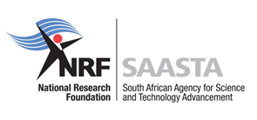
NATIONAL SCIENCE WEEK 2017

ORGANISATION NAME: |  |  |  | - Nelson Mandela Bay Science & Technology Centre
CONNECT WITH US ONLINE |  |  | Twitter: |  | >
 |  |  | Facebook: |  | - Nelson Mandela Bay Science & Technology Centre
 |  |  | Website: |  | - Uitenhage Despatch Development Initiative
DATE OF ACTIVITY | DISTRICT WHERE ACTIVITY BEING HELD | VENUE WHERE ACTIVITY IS TAKING PLACE | ACTIVITIES  (Provide a short description of the activity) |  |  | TARGET AUDIENCE | TIMESLOT | CONTACT PERSON  EMAIL ADDRESS  PHONE NUMBER | BOOKING REQUIRED  (YES OR NO)
07 August 2017 | Nelson Mandela Bay Municipality | Nelson Mandela Bay Science & Technology Centre | The learners & educators will be visiting the Nelson Mandela Bay Science & Technology Centre where they will explore and interact with different exhibits on Automotive, Energy & electricity, momentum Biology & life, etc. The visit will include talks by a Stats lecturer and a PhD candidate from Rhodes University. The talks aim to expose the learners to the different career opportunities in STEM focusing more on Chemistry and Statistics.  The will learners will also be introduced to the African indigenous strategic game called Mankala and they will have also have the opportunity to explore more about Stats through interactive activities. |  |  | 240 learners & 8 teacher ( grade 9,10 & 11 learners) | 09:00 – 11:00  12:00 – 14:00 | Noma/Singa  041 991 5000  singa@uddi.co.za  Noma@uddi.co.za | No  Invited schools only
07 August 2017 | Nelson Mandela Bay Municipality | Bayworld Museum | The students will be taken on an excursion to the Bayworld Museum where they will explore the different exhibits which focus on the History of Maritime, The history and development of the Xhosa culture, the genealogy and beadwork, exhibits which showcase the cultural practices of the indigenous people of the Bay and many more. The students will also have the opportunity to see the snake part and the oceanarium. |  |  | 60 students | 10:00 – 13:00 | Noma/Singa  041 991 5000  singa@uddi.co.za  Noma@uddi.co.za | Invited students only
08 August 2017 | Sarah Baartman District | Vukani Primary School & Hankey Primary School | The leaners and educators will be involved in an interactive fun science show, hands-on mathematics activities and chemistry activities. There will also be talks by the Nelson Mandela Bay Science & Technology Team to expose the learners to the different careers in STEM focusing mainly on Biotechnology, Chemistry, environmental science and Mathematics. |  |  | 200 leaners and 10 educators | 09:00 – 11:00  12:00 – 14:00 | Noma/Singa  041 991 5000  singa@uddi.co.za  Noma@uddi.co.za | Invited schools only
08 August 2017 | Nelson Mandela Bay Municipality |  | The learners and parents will be taken on an excursion to the Bayworld Museum where they will explore the different exhibits which focus on the History of Maritime, The history and development of the Xhosa culture, the genealogy and beadwork, exhibits which showcase the cultural practices of the indigenous people of the Bay and many more. The learners and parents will also have the opportunity to see the snake |  |  | 60 learners and 60 parents (grade 6, 7 leaners) | 10:00 – 13:00 | Noma/Singa  041 991 5000  singa@uddi.co.za  Noma@uddi.co.za | Invited learners & parents only
10 August 2017 | Nelson Mandela Bay Municipality | Nelson Mandela Bay Science & Technology Centre | The learners & educators will be visiting the Nelson Mandela Bay Science & Technology Centre where they will explore and interact with different exhibits on Automotive, Energy & electricity, momentum Biology & life, etc. The visit will include talks by a Pharmacy lecturer from Rhodes University and a postgraduate student from NMMU and an NMBSC staff. The talks aim to expose the learners to the different career opportunities in STEM focusing more on Pharmacy, Chemistry and Biotechnology.  The learners & teachers will also have an opportunity to do a hands-on interactive pharmacy, chemistry and biotechnology experiments. |  |  | 240 learners and 8 teachers (6,7,9,10,11) | 09:00 – 11:00  12:00 – 14:00 | Noma/Singa  041 991 5000  singa@uddi.co.za  Noma@uddi.co.za | Invited schools only
11 August 2017 | Nelson Mandela Bay Municipality | Kwanobuhle Shopping Complex and Lovelife Youth Radio | The Nelson Mandela Bay Science & Technology Centre team will setup an exhibition stall at the Kwanobuhle Shopping Complex, where the public could have the opportunity to interact with the exhibits, while being exposed to science shows which focus on everyday life concepts. There will also be competitions for the community members. We will also have a slot at the Lovelife youth radio where we will be talking about The National Science Week and the Importance of STEM. |  |  | 500 community members | 10:00 – 15:00 | Noma/Singa  041 991 5000  singa@uddi.co.za  Noma@uddi.co.za | No

