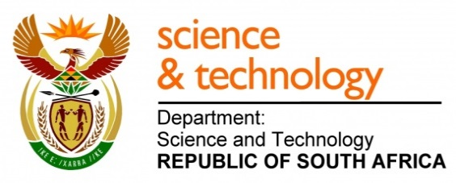
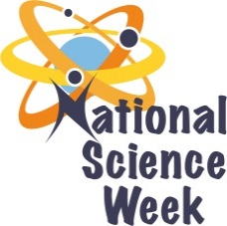
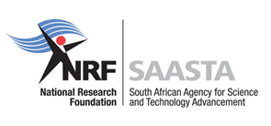
NATIONAL SCIENCE WEEK 2017

ORGANISATION NAME: |  |  |  | >MOIPONE ACADEMY
CONNECT WITH US ONLINE |  |  | Twitter: |  | >@MOIPONE_ACADEMY
 |  |  | Facebook: |  | >@MoiponeAcademy
 |  |  | Website: |  | >www.saastec.co.za
DATE OF ACTIVITY | DISTRICT WHERE ACTIVITY BEING HELD | VENUE WHERE ACTIVITY IS TAKING PLACE | ACTIVITIES  (Provide a short description of the activity) |  |  | TARGET AUDIENCE | TIMESLOT | CONTACT PERSON  EMAIL ADDRESS  PHONE NUMBER | BOOKING REQUIRED  (YES OR NO)
5 August 2017 | Ekurhuleni District | Rabasotho Hall - Tembisa | Official opening, Presentations, Role modelling lecture, Exhibition and science shows demonstrations |  |  | General Public | 9h00 – 14h00 | Joseph Taetsane  taetsanelj@gmail.com  0829798898 | No
7 August 2017 | Ekurhuleni District | Khayalothando Hall - Tembisa | Role modelling lecture, hands on science experiments & interactive exhibits, Robotics and Computer lessons |  |  | Learners & Educators | 13h00 – 17h00 | Joseph Taetsane  taetsanelj@gmail.com  0829798898 | Yes
8 August 2017 | Johannesburg  District | Ivory Park Hall - Midrand | Role modelling lecture, hands on science experiments & interactive exhibits, Robotics and Computer lessons |  |  | Learners & Educators | 13h00 – 17h00 | Joseph Taetsane  taetsanelj@gmail.com  0829798898 | Yes
9 August 2017 | Ekurhuleni District | Moses Molelekwa Centre- Tembisa | Role modelling lecture, hands on science experiments & interactive exhibits, Robotics and Computer lessons |  |  | General Public – mainly woman | 9h00 – 14h00 | Joseph Taetsane  taetsanelj@gmail.com  0829798898 | No
10 August 2017 | Ekurhuleni & Tshwane District | Sam Hlalele Hall - Tembisa | Site visit to CSIR - presentations, tours, exhibitions and interactive demonstrations  Role modelling lecture, hands on science experiments & interactive exhibits, Robotics and Computer lessons |  |  | Learners & Educators | 9h00 – 14h00  13h00 – 17h00 | Joseph Taetsane  taetsanelj@gmail.com  0829798898 | Yes
11 August 2017 | Ekurhuleni District | DH Williams Hall - Katlehong | Role modelling lecture, hands on science experiments & interactive exhibits, Robotics and Computer lessons |  |  | Learners & Educators | 13h00 – 17h00 | Joseph Taetsane  taetsanelj@gmail.com  0829798898 | Yes
12 August 2017 | Tshwane District | Freedom Park | Tour - to promote, protect and preserve Indigenous Knowledge Systems (IKS) and Tourism |  |  | General Public | 9h00 – 14h00 | Joseph Taetsane  taetsanelj@gmail.com  0829798898 | Yes

