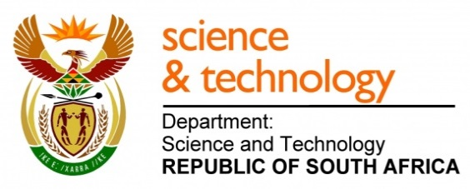
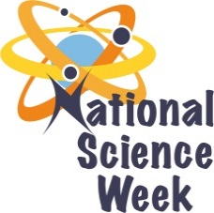
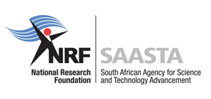
NATIONAL SCIENCE WEEK 2017

ORGANISATION NAME: |  |  |  | - Kleva Nkeva
CONNECT WITH US ONLINE |  |  | Twitter: |  | - @klevankeva
 |  |  | Facebook: |  | - Kleva Nkeva
 |  |  | Website: |  | - www.clevankeva.co.za
DATE OF ACTIVITY | DISTRICT WHERE ACTIVITY BEING HELD | VENUE WHERE ACTIVITY IS TAKING PLACE | ACTIVITIES  (Provide a short description of the activity) |  |  | TARGET AUDIENCE | TIMESLOT | CONTACT PERSON  EMAIL ADDRESS  PHONE NUMBER | BOOKING REQUIRED  (YES OR NO)
07/08 | OR Tambo | Mxhume S.S. S | Electrodes: The audience will participate in an experiment of proving that voltaic energy can be generated from a combination of coins and cents, using different solutions as a catalyst. This experiment will be conducted using aluminium foil, tissue paper, conductor wires and the multi-meter to indicate the findings.  Solar Energy: The purpose of this exhibition is to show how innovation using solar alternative energy could benefit the community in saving electricity and money. The audience will be learning new innovations in alternative energy sources and the excitement in science of discovery.  The model of exhibition will be the solar cooker. It uses the sun rays to heat up the steel used for cooking purposes.  Introduction to map reading N&S orientation and remote sensing. This will increase interest in spatial sciences and get the audience interested in charting their environment.  Time Zones:  demystify the science of times zones while connecting it to international tourism.  Indigenous Tourism Systems:  The aim of the activity is showcase the indigenous knowledge encompassed by local tourist guides. This will tap into the indigenous tools they use to navigate our part of the Wild Coast.  Aquaculture:  identify and taxonomically classify organisms that they will have observed up to species level where possible  Participants will be able to distinguish between animals that are inhabitants of rocky shores to those that are inhabitants of sandy shores |  |  | 250 learners  100 General public | 8am – 10 am  10am -12 pm  12pm – 2pm  2pm – 3 pm | Electrodes-  Msimelelo@clevankeva.co.za  Solar Energy/Map Navigation:  themba@klevankeva.co.za  Time Zones –  siwa@clevankeva.co.za | NO
08/08 | OR Tambo | Holy Cross | Electrodes: The audience will participate in an experiment of proving that voltaic energy can be generated from a combination of coins and cents, using different solutions as a catalyst. This experiment will be conducted using aluminium foil, tissue paper, conductor wires and the multi-meter to indicate the findings.  Solar Energy: The purpose of this exhibition is to show how innovation using solar alternative energy could benefit the community in saving electricity and money. The audience will be learning new innovations in alternative energy sources and the excitement in science of discovery.  The model of exhibition will be the solar cooker. It uses the sun rays to heat up the steel used for cooking purposes.  Introduction to map reading N&S orientation and remote sensing. This will increase interest in spatial sciences and get the audience interested in charting their environment.  Time Zones:  demystify the science of times zones while connecting it to international tourism.  Indigenous Tourism Systems:  The aim of the activity is showcase the indigenous knowledge encompassed by local tourist guides. This will tap into the indigenous tools they use to navigate our part of the Wild Coast.  Aquaculture:  identify and taxonomically classify organisms that they will have observed up to species level where possible  Participants will be able to distinguish between animals that are inhabitants of rocky shores to those that are inhabitants of sandy shores |  |  | 250 learners  100 General public | 8am – 10 am  10am -12 pm  12pm – 2pm  2pm – 3 pm | Electrodes-  Msimelelo@clevankeva.co.za  Solar Energy/Map Navigation:  themba@klevankeva.co.za  Time Zones –  siwa@clevankeva.co.za | NO
09/08 |  | Resource Center | The day’s programme will be based on women’s day celebrations, with key note speakers from influential local women. Then proceeding with the day’s exhibitions and other programmes. |  |  | 60 learners  150 General public | 9am – 3pm | info@clevankeva.co.za | Yes
10/08 | OR Tambo | Ndindindi/Njombela | Electrodes: The audience will participate in an experiment of proving that voltaic energy can be generated from a combination of coins and cents, using different solutions as a catalyst. This experiment will be conducted using aluminium foil, tissue paper, conductor wires and the multi-meter to indicate the findings.  Solar Energy: The purpose of this exhibition is to show how innovation using solar alternative energy could benefit the community in saving electricity and money. The audience will be learning new innovations in alternative energy sources and the excitement in science of discovery.  The model of exhibition will be the solar cooker. It uses the sun rays to heat up the steel used for cooking purposes.  Introduction to map reading N&S orientation and remote sensing. This will increase interest in spatial sciences and get the audience interested in charting their environment.  Time Zones:  demystify the science of times zones while connecting it to international tourism.  Indigenous Tourism Systems:  The aim of the activity is showcase the indigenous knowledge encompassed by local tourist guides. This will tap into the indigenous tools they use to navigate our part of the Wild Coast.  Aquaculture:  identify and taxonomically classify organisms that they will have observed up to species level where possible  Participants will be able to distinguish between animals that are inhabitants of rocky shores to those that are inhabitants of sandy shores |  |  | 250 learners  100 General public | 8am – 10 am  10am -12 pm  12pm – 2pm  2pm – 3 pm | Electrodes-  Msimelelo@clevankeva.co.za  Solar Energy/Map Navigation:  themba@klevankeva.co.za  Time Zones –  siwa@clevankeva.co.za | No
11/08 |  | Hiking/Tour | The innovation competition winners will be taken on the coastal tour of Mpondoland learning about rock formation, sustainable tourism innovation, map reading and navigation, and aquaculture. Later invite the local public community members on an astro gazing expedition. |  |  | 20 people for hike then 100 for other exhibitions | 7am – 2pm | siwa@clevankeva.co.za | YES

