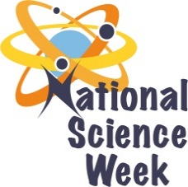
NATIONAL SCIENCE WEEK 2017

ORGANISATION NAME: |  |  | >KATEKANI NATHI
CONNECT WITH US ONLINE |  |  | Twitter: | - N/A
 |  |  | Facebook: | - N/A
 |  |  | Website: | - N/A
DATE OF ACTIVITY | DISTRICT WHERE ACTIVITY BEING HELD | VENUE WHERE ACTIVITY IS TAKING PLACE | ACTIVITIES  (Provide a short description of the activity) |  | TARGET AUDIENCE | TIMESLOT | CONTACT PERSON  EMAIL ADDRESS  PHONE NUMBER | BOOKING REQUIRED  (YES OR NO)
10 August 2017 | Bushbuckridge | Njanji Primary School  Chayeza Secondary School | - Water saving lecture  - A discussion with the learner will be conducted to establish way of saving water  - Maths games  - Learners will complete a magic square table of 24 and magic triangles |  | Learners & Educators | 3 Hours | Malumane Damaris  082 5815 347 | No
11 August 2017 | Bushbuckridge | Thulani Primary School  Dumisani Secondary School | - Water saving lecture  - A discussion with the learner will be conducted to establish way of saving water  - Maths games  - Learners will complete a magic square table of 24 and magic triangles |  | Learners & Educators | 3 Hours | Malumane Damaris  082 5815 347 | No
12 August 2017 | Bushbuckridge | Shopping Complex | - Road Shows at shopping complex  - Team members will be engaging general public about science week, the importance of maths and science in the country and scarce skills |  | Public | 6 Hours | Malumane Damaris  082 5815 347 | No

