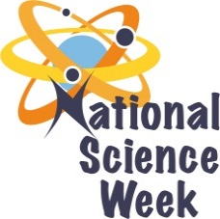
NATIONAL SCIENCE WEEK 2017

ORGANISATION NAME: |  |  |  | >Johannesburg City Parks and Zoo
CONNECT WITH US ONLINE |  |  | Twitter: |  | > https://www.facebook.com/JohannesburgZoo/
 |  |  | Facebook: |  | > https://www.facebook.com/JoburgParks/
 |  |  | Website: |  | >www.jhbcityparks.com
DATE OF ACTIVITY | DISTRICT WHERE ACTIVITY BEING HELD | VENUE WHERE ACTIVITY IS TAKING PLACE | ACTIVITIES  (Provide a short description of the activity) |  |  | TARGET AUDIENCE | TIMESLOT | CONTACT PERSON  EMAIL ADDRESS  PHONE NUMBER | BOOKING REQUIRED  (YES OR NO)
8/08/2017 | City of Johannesburg | Pennyville | Community members would be engaged interactive activities that promote science engagement. |  |  | 700 General Public | 10am -13h00 | smagolo@jhbcityparks.com  011 782 9597  0798981761 | No
7/08/2017 | City of Johannesburg | Johannesburg  Zoo | Learners would be engaged in science for tourism activities by meeting the different scientist at the zoo and engaging in activities. |  |  | 300 learners | 9.30am – 12.30pm | smagolo@jhbcityparks.com  011 782 9597  0798981761 | Yes
10/08/2017 | City of Johannesburg | JBG EE Centre | Learners would be involved in hands on science activities at the science centre at the botanical gardens. |  |  | 300 learners | 9.30am – 12.30pm | smagolo@jhbcityparks.com  011 782 9597  0798981761 | Yes

