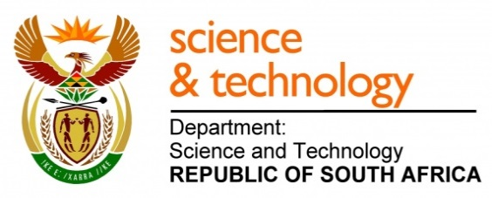
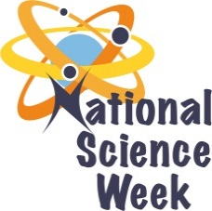
NATIONAL SCIENCE WEEK 2017

ORGANISATION NAME: |  |  |  | >GIYANI SCIENCE CENTRE
CONNECT WITH US ONLINE |  |  | Twitter: |  | >
 |  |  | Facebook: |  | >
 |  |  | Website: |  | >
DATE OF ACTIVITY | DISTRICT WHERE ACTIVITY BEING HELD | VENUE WHERE ACTIVITY IS TAKING PLACE | ACTIVITIES  (Provide a short description of the activity) |  |  | TARGET AUDIENCE | TIMESLOT | CONTACT PERSON  EMAIL ADDRESS  PHONE NUMBER | BOOKING REQUIRED  (YES OR NO)
05/08/17 | GREAT GIYANI | BEND STORE |  |  |  | GENERAL PUBLIC | 09H00 | MR MTHEMBI  0720131076 | NO
07/08/17 | GREAT GIYANI | GIYANI SCIENCE CENTRE |  |  |  | LEARNERS ANDA TEARCHERS | 09H00 | MR MTHEMBI  0720131076 | NO
08/08/17 | MOPANI | SEKGOPO |  |  |  | GENERAL PUBLIC | 09H00 | MR MTHEMBI  0720131076 | NO
09/08/17 | MOPANI | ELIM COMPLEX |  |  |  | GENERAL PUBLIC | 09H00 | MR MTHEMBI  0720131076 | NO
10/08/17 | GREAT LETABA | WHOLESALE |  |  |  | GENERAL PUBLIC | 09H00 | MR MTHEMBI  0720131076 | NO
11/08/17 | WATERBERG | MEDUPI |  |  |  | GENERAL PUBLIC | 09H00 | MR MTHEMBI  0720131076 | NO
12/08/17 | LIM 345 | SALEMA COMPLEX |  |  |  | GENERAL PUBLIC | 09H00 | MR MTHEMBI  0720131076 | NO

