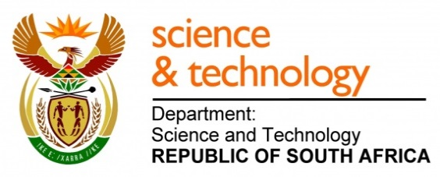
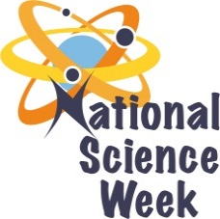
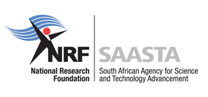
NATIONAL SCIENCE WEEK 2017

ORGANISATION NAME: |  |  |  | >ArcelorMittal Transformation Centre NPC
CONNECT WITH US ONLINE |  |  | Twitter: |  | >
 |  |  | Facebook: |  | > https://www.facebook.com/sciencecentresaldanha.arcelormittal
 |  |  | Website: |  | > http://arcelormittalsa.com
DATE OF ACTIVITY | DISTRICT WHERE ACTIVITY BEING HELD | VENUE WHERE ACTIVITY IS TAKING PLACE | ACTIVITIES  (Provide a short description of the activity) |  |  | TARGET AUDIENCE | TIMESLOT | CONTACT PERSON  EMAIL ADDRESS  PHONE NUMBER | BOOKING REQUIRED  (YES OR NO)
05/08/2017  12/08/2017 | #52  West Coast District Municipality | Weskus Mall & Langebaan Community Centre. | An 8-hour programme with various activities that will expose the value of Science in conjunction with tourism. It ranges from fun activities such as marshmallow tower building, Math fun quizzes in calculating population and traveling distances. An Eskom Expo that motivates public interests in STEMI. Water quality workshops that emphasize on the value of water and the economy’s sustainable future of Tourism. Including other fun science experiments, volcano building. |  |  | General Public | 08:00-17:00 | Jacqueline Willems- Project Coordinator  jacquewillems@hotmail.com  022-7191058  Lekgabe Dihlabi- Educational Officer  lekgabe@amsasciencecentre.co.za  Olivia -Bookings manager  Info@weskus-mall.co.za | No
07/08/2017  08/08/2017 | #52  West Coast District Municipality | Louwville HS & Diazville HS | Water Care and Water Quality Workshops at Louwville HS & Diazville HS. With the Department of Water & Sanitation the workshops will educate learners the value of water recycling and preservation. Actively testing various water qualities and highlighting the Science behind the preservation and care of water/water systems. How water influences our Tourism industries. |  |  | Learners  Grade 10 & 11 | 09:00-13:00 | Lekgabe Dihlabi- Educational Officer lekgabe@amsasciencecentre.co.za  022-7191058  Mr E Petrus- Louwville HS  emile.petrus@wcgschools.gov.za  Mr. Vraagom- Diazville HS  diazville.high@wcgschools.gov.za  Mr Vraagom-Weston HS  westonhsvredenburg@gmail.com | No
7/08/2017 | Circuit 3  West Coast District Municipality | Piketberg Primary | Fun Science and Math activities aligned to the curriculum. Science Centre staff accompanied by a Math Facilitator will go to Piketberg primary school and implement a series of fun Math and Science activities and tricks that are aligned to the curriculum. |  |  | Grade 4-7 Learners | 10:00-13:00 | Mr. Slinger Physics Eudutainer  lucas@amsasciencecentre.co.za  022-7191058  Mr P. Mettler -Mathematic facilitator | No
07/08/2017  08/08/2017  10/08/2017  11/08/2017 | #52  West Coast District Municipality | West Coast Fossil Park | Fossil Park Excursion for Advancing Tourism. Exposing learners to a heritage site that host great fossils and exciting activities to explore the purpose of science in the preservation of this touristic site. Activities such as mock digging, visiting the fossil sites and learning about bones and the scientific interpretation to obtain valuable historic data. |  |  | Learners-  Grade 6 | 08:30-14:00 | Siphosethu Legoabe- Educational Officer (022) 7191058  dudu@amsasciencecentre.co.za  edu@fossilpark.org.za  info@fossilpark.org.za | Yes
9/08/2017 | #52  West Coast District Municipality | !IKhwattu  R45  Yzerfontein | Women in Science: Celebrating women in Science with young inspiring scientist that will encourage grade 10 & grade 11 girl learners with STEM careers. Learners will explore the value of indigenous systems and its scientific and touristic value at !IKhwattu. This is in conjunction with Woman’s day. |  |  | Learners-  Grade 10 & grade 11 | 08:00-16:00 | Adrienne@amsasciencecentre.co.za  Jacquewillems@hotmail.com  lekgabe@amsasciencecentre.co.za  022-7191058  info@khwattu.org | Yes
07/08/2017  08/08/2017  10/08/2017 | #52  West Coast District Municipality | Hopefield Community Hall,  St Helena Bay Primary, NoordHoek Primary. | Chess Clinic: Over three days the event will be hosted in regions where there is very little opportunity to be exposed to the mental sport of chess. A game that requires concentration and strategic planning and that has international Tourism value. |  |  | General public | 14:00-18:00 | Lekgabe Dihlabi- Educational Officer lekgabe@amsasciencecentre.co.za  Jacqueline Willems-Project Coordinator  jacquewillems@hotmail.com  022-7191058  Nathan Kamalie-Wes Coast Chess Union, Instructor and trainer  Cell:0765572782  nkamalie@gmail.com | No
08/08/2017  10/08/2017 | #52  West Coast District Municipality | ArcelorMittal Transformation Centre | Teachers’ Workshops: Targeting primary teachers in interactive teaching solutions which they can implement in their lessons at school. They will learn how to make soap and assess the salt levels in sea water. |  |  | Educators | 15:00-16:30 | Lucas Slinger- Educational Officer  lucas@amsasciencecentre.co.za  022-7191058 | Yes
11/08/2017 | #52  West Coast District Municipality | ArcelorMittal Transformation Centre- Science Centre Vredenburg | Discover the West Coast is an event aimed at grade 9 learners that will visit the Science Centre that will host various activities to discover the value of science of Tourism. How key stakeholders support tourism and how to preserve the value of our biodiversity in the West Coast specifically. To create awareness around STEMI careers and the importance of science contribution to the local economy. Collaborating with ArcelorMittal engineers and the department of Water and Sanitation to expose the public, learners and students to the value of science in the context of tourism. |  |  | Grade 9 Learners  Decision Makers  General Public | 08:30-13:00 | Jacqueline Willems-Project Coordinator  jacquewillems@hotmail.com  022-7191058  Adrienne Domorog  adrienne@amsasciencecentre.co.za  Lekgabe Dihlabi- Educational Officer lekgabe@amsasciencecentre.co.za  Sabelo Maqana- Dept. Water & Sanitation | No

