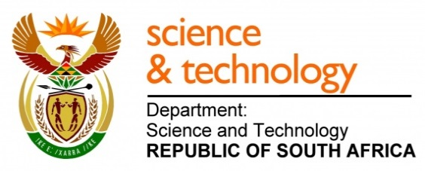
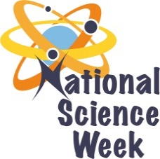
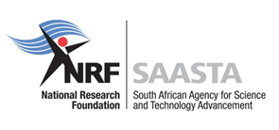
NATIONAL SCIENCE WEEK 2017

ORGANISATION NAME: |  |  |  | - ArcelorMittal Science Centre (Newcastle)
CONNECT WITH US ONLINE |  |  | Twitter: |  | >
 |  |  | Facebook: |  | - ArcelorMittal Science Centre - NN
 |  |  | Website: |  | - www.arcelormittalsa.com/BBBEE/SocioeconomicDevelopment/ScienceCentre
DATE OF ACTIVITY | DISTRICT WHERE ACTIVITY BEING HELD | VENUE WHERE ACTIVITY IS TAKING PLACE | ACTIVITIES  (Provide a short description of the activity) |  |  | TARGET AUDIENCE | TIMESLOT | CONTACT PERSON  EMAIL ADDRESS  PHONE NUMBER | BOOKING REQUIRED  (YES OR NO)
05 August 2017 | UThukela District Municipality | Murchison Mall (Ladysmith) | Exhibition, Science Show and Maths challenges |  |  | General Public | 09h00 – 16h00 | Manqoba Ndhlela  manqoba@amsasciencecentre.co.za  034 314 1247 | Yes
7,8,10,11 August 2017 | Majuba District Municipality | ArcelorMittal Science Centre | Puppet Show  Maths Workshop  Identification of Plant Cell |  |  | Learners  (Grade 3)  (Grade 6)  (Grade 10) | 09h00 - 11h00  11h00 – 13h00 | Manqoba Ndhlela  manqoba@amsasciencecentre.co.za  034 314 1247 | No
08 August 2017 | Majuba District Municipality | Osizweni  &  Newcastle | Exhibition, Science Show and Maths challenges |  |  | General Public | 14h00 – 16h00  14h00 – 16h00 | Manqoba Ndhlela  manqoba@amsasciencecentre.co.za  034 314 1247 | No
09 August 2017 | Majuba District Municipality | ArcelorMittal Science Centre | Science Café ( Talk from female professionals) |  |  | General Public  (Women) | 10h00 – 15h00 | Manqoba Ndhlela  manqoba@amsasciencecentre.co.za  034 314 1247 | No
12 August 2017 | uMzinyathi District Municipality | Dundee Taxi Rank | Exhibition, Science Show and Maths challenges |  |  | General Public | 09h00 – 16h00 | Manqoba Ndhlela  manqoba@amsasciencecentre.co.za  034 314 1247 | Yes

