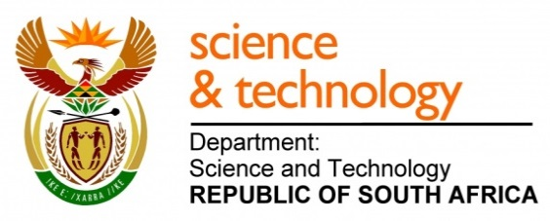
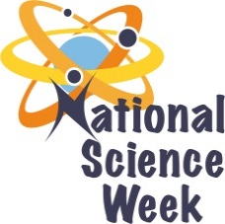
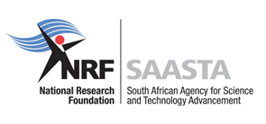
NATIONAL SCIENCE WEEK 2017

ORGANISATION NAME: |  |  |  | > African Institute for Mathematical Sciences
CONNECT WITH US ONLINE |  |  | Twitter: |  | > @AIMSacza
 |  |  | Facebook: |  | > AIMS South Africa
 |  |  | Website: |  | > www.aims.ac.za
DATE OF ACTIVITY | DISTRICT WHERE ACTIVITY BEING HELD | VENUE WHERE ACTIVITY IS TAKING PLACE | ACTIVITIES  (Provide a short description of the activity) |  |  | TARGET AUDIENCE | TIMESLOT | CONTACT PERSON  EMAIL ADDRESS  PHONE NUMBER | BOOKING REQUIRED  (YES OR NO)
7-10 August | City of Cape Town Metropolitan Municipality | Oliver Tambo Community Hall, Khayelitsha, Cape Town | School programme  Practical hands-on activities, science shows, career guidance, role modelling talks and exhibits  STEM hands-on activities:  - Engineering of Transportation  - Basket Weaving and Geometric Patterns  - Lantern Making and Platonic Polyhedra Models  - Pottery and Volume  - Surface area of cubes  - World Map Puzzle  - Mathematics games (e.g. 21 cards, rubiks cube, etc.) and Maths quiz  - Electromagnetism  - Programming in Scratch  Talks  - Applications of Mathematics (in other fields)  - Water Conservation  - Career guidance and role modelling  - Mathematics and Music  AIMS Research Centre exhibition  - IMAGINARY Exhibition  - Mathematics behind Agriculture  - Mathematics behind Robotics  - Mathematics behind SKA  - Mathematics behind Movies  - Mathematics behind ESKOM load shedding  - Mathematics and Epidemics  - Data Science  - Mathematics behind Network Science  Local STEM organisations and higher education institutions will showcase their exciting work, conduct interactive demonstrations for learners, university students and members of the public.  For more information visit  https://sites.google.com/aims.ac.za/nsw2017 |  |  | Grade 7-12 learners and educators | 8:30 – 15:30  14:45 – 16:30 (PUBLIC) | Dr Mpfareleni Rejoyce Gavhi-Molefe  nsw@aims.ac.za  021 787 9349 | Booking essential for schools
8 August | City of Cape Town Metropolitan Municipality | African Institute for Mathematical Sciences, Muizenberg | Public Talk |  |  | Public | 19:00-20:00 | Dr Mpfareleni Rejoyce Gavhi-Molefe  nsw@aims.ac.za  021 787 9349 | No
9 August | City of Cape Town Metropolitan Municipality | Oliver Tambo Community Hall, Khayelitsha, Cape Town | Women in science, technology, engineering, and math (STEM) fields |  |  | Learners and public | TBC | Dr Mpfareleni Rejoyce Gavhi-Molefe  nsw@aims.ac.za  021 787 9349 | No

