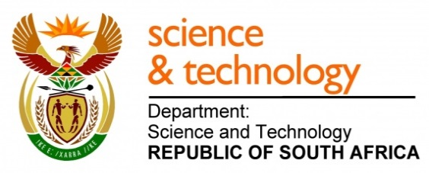
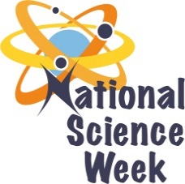
NATIONAL SCIENCE WEEK 2017

ORGANISATION NAME: |  |  |  | - ORANGE GALAXY
CONNECT WITH US ONLINE |  |  | Twitter: |  | - ORG_alaxy
 |  |  | Facebook: |  | - ORANGE GALAXY
 |  |  | Website: |  | - TBA
DATE OF ACTIVITY | DISTRICT WHERE ACTIVITY BEING HELD | VENUE WHERE ACTIVITY IS TAKING PLACE | ACTIVITIES  (Provide a short description of the activity) |  |  | TARGET AUDIENCE | TIMESLOT | CONTACT PERSON  EMAIL ADDRESS  PHONE NUMBER | BOOKING REQUIRED  (YES OR NO)
07-11 August 2017 | Moses Kotane  Mogwase | Kwena Tlase High | Exhibition: showcasing innovations in and around the district, Career guidance by various institutions and student projects showcased. |  |  | Learners, General Public, Journalists, Educators, Decision Makers, etc | 09h00 to 16h00 | Kgomotso Mooko  0728351369 | No
07 August 2017 | Moses Kotane  Mogwase | Kwena Tlase High | Official Opening |  |  | ALL | 09h00-10h00 | Kgomotso Mooko  0728351369 | No
08-11 August 2017 | Moses Kotane  Mogwase | Kwena Tlase High | Demonstrations by various Institutions and Innovators , workshops, maths activities, quizzes, debates ,presentations by different science experts. |  |  | Learners ,Jouranalist, Educators and Decision Makers | 09h00-16h00 | Kgomotso Mooko  0728351369 | No
10 August 2017 | Moses Kotane | Kwena Tlase High | Agro Processing Workshop |  |  | Farmers | 10h00-12h00 | Kgomotso Mooko  0728351369 | No
10 August 2017 | Moes Kotane | Kwena Tlase  High | Career Guidance Workshop and Presentations |  |  | Learners | 09h00-12h00 | Kgomotso Mooko  0728351369 | No

