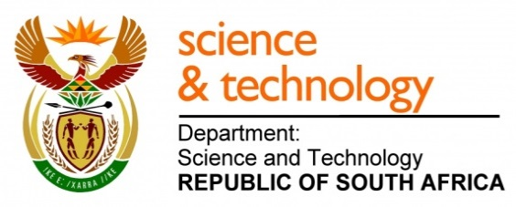
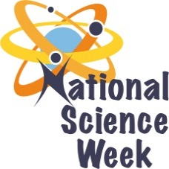
NATIONAL SCIENCE WEEK 2017

ORGANISATION NAME: |  |  |  | >MATHS OUR WORLD
CONNECT WITH US ONLINE |  |  | Twitter: |  | >@mathsour
 |  |  | Facebook: |  | >maths our world
 |  |  | Website: |  | >www.mathsourworld.org
DATE OF ACTIVITY | DISTRICT WHERE ACTIVITY BEING HELD | VENUE WHERE ACTIVITY IS TAKING PLACE | ACTIVITIES  (Provide a short description of the activity) |  |  | TARGET AUDIENCE | TIMESLOT | CONTACT PERSON  EMAIL ADDRESS  PHONE NUMBER | BOOKING REQUIRED  (YES OR NO)
05/08/2017  To 09/08/2017 | Ekurhuleni | Golden walk mall. Germiston | Family Maths- helping parents become more involved in their children’s maths education  It has been proven that family involvement in the education of children has a great deal of benefits. In this activity, the facilitator will use games to discuss various mathematical concepts with learners and parents. The facilitator will demonstrate how maths is expressed in various daily activities like waking up in the morning, going to school, going to the grocery store, counting money, telling time, fractions etc. The facilitator will also show that learners and parents can make their own mathematical games from recycled material. |  |  | 1000 | 10am -12pm | Lihle-  076 806 2507 | Yes
07/08/2017 to 11/08/2017 | Ekurhuleni | Ekurhuleni Primary School | MATHS GAMES WITH LEARNERS  Lack of maths skills can have very negative effects on people, they can get robbed, get taken advantage of or make wrong decision and what can be considered silly mistakes. Basic mathematical concepts can therefore improve one’s quality of life. These concepts will empower them to be able to be independent, make informed decision about different things, plan better, save better and live a better life |  |  | 500 | 8am – 10am | Farai  074 720 0397 | No
07/08/2017 to 09/08/2017 | Bojanala | Rabboni Christian School | DENSITY DEMONSTRATION TO LEARNERS  Chemistry lessons don’t have to be boring. With a couple of eggs and a little salt you can teach your child all about the concept of density. Science is everywhere and the ingredients for illustrating important scientific concepts are right in the kitchen for the learners every day. |  |  | 500 | 8am – 10am | Josline  081 793 1750 | No
10/08/2017 to 11/08/2017 | Bojanala | Jethro Pelle Secondary School | MATHS GAMES WITH LEARNERS  Lack of maths skills can have very negative effects on people, they can get robbed, get taken advantage of or make wrong decision and what can be considered silly mistakes. Basic mathematical concepts can therefore improve one’s quality of life. These concepts will empower them to be able to be independent, make informed decision about different things, plan better, save better and live a better life |  |  | 500 | 8am – 10am | Tom  078 267 7770 | No
07/08/2017 to 11/08/2017 | Ekurhuleni | Fumana Secondary School | Kitchen and Bathroom science  In this activity, the facilitator will demonstrate to learners that they can carry out a number of science experiments using common household items found in their kitchen and bathroom. These activities will include the toothpaste activity. |  |  | 500 | 8am – 10am | Shoki  079 342 5122 | No
07/08/2017 to 08/08/2017 | Tshwane | Ditsong museum | Visit to the Natural History Museum  This activity will involve the participants visiting the DITSONG National History Museum in Pretoria. The museum has a variety of education programs for learners. These programs are linked to the curriculum. Schools use the museum to bring to life what the learners are taught at school. The learners will visit the museum for a guided tour program that is tailor made for their specific grade. A museum guide will take them through the various displays and explain all the exhibits. It will be a fun educational visit. |  |  | 240 | 9am – 11am | Bongi  083 541 7213 | Yes
10/08/2017 | Tshwane | Ditsong museum | Visit to the Discovery centre at the Natural History Museum  This activity will involve the participants visiting the Discovery centre at the DITSONG National History Museum in Pretoria. The Discovery centre is a hands-on activity centre, where the five human senses are used to discover the wonders of nature, offering an invaluable educational adventure. It affords easy access for wheelchairs and display texts are also transcribed in Braille. This centre is ideal for younger learners that are eager to explore with their hands, noses, tongues, eyes and ears. It is a different experience from a museum visit in that it is more practical and the get to handle the displays and not just look at them. |  |  | 60 | 9am – 11am | Bongi  083 541 7213 | Yes

