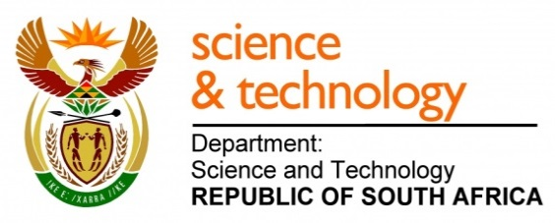
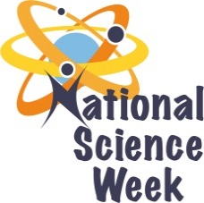
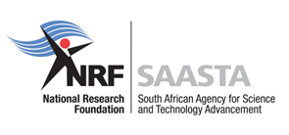
NATIONAL SCIENCE WEEK2017

ORGANISATION NAME: |  |  |  | South African Astronomical Observatory: NC Activities
CONNECT WITH US ONLINE |  |  | Twitter: |  | >
 |  |  | Facebook: |  | >
 |  |  | Website: |  | >
DATE OF ACTIVITY | DISTRICT WHERE ACTIVITY BEING HELD | VENUE WHERE ACTIVITY IS TAKING PLACE | ACTIVITIES  (Provide a short description of the activity) |  |  | TARGET AUDIENCE | TIMESLOT | CONTACT PERSON  EMAIL ADDRESS  PHONE NUMBER | BOOKING REQUIRED  (YES OR NO)
07 August 2017 | Namaqua | Lekkersing Primary School | Universal Awareness: Astronomy Story Telling |  |  | Grades 1 - 3 | 09:00 – 10:30 | Anthony Mietas asm@saao.ac.za or 0743301236 | yes
 |  |  | Building of Telescope workshop |  |  | Grades 6-7 | 10:45 – 12:00 | Anthony Mietas asm@saao.ac.za or 0743301236 | yes
 |  |  | Solar System Workshop |  |  | Grades 8-12 | 12:15- 13:15 | Anthony Mietas asm@saao.ac.za or 0743301236 | yes
 |  |  | Stargazing |  |  | public | 18:00 – 20:00 | Anthony Mietas asm@saao.ac.za or 0743301236 | yes
08 August 2017 | Namaqua | Port Nolloth | Universal Awareness: Astronomy Story Telling |  |  | Grades 1 - 3 | 09:00 – 10:30 | Anthony Mietas asm@saao.ac.za or 0743301236 | yes
 |  |  | Building of Telescope workshop |  |  | Grades 6-7 | 10:45 – 12:00 | Anthony Mietas asm@saao.ac.za or 0743301236 | yes
 |  |  | Solar System Workshop |  |  | Grades 8-12 | 12:15- 13:15 | Anthony Mietas asm@saao.ac.za or 0743301236 | yes
 |  |  | Stargazing |  |  | public | 18:00 – 20:00 | Anthony Mietas asm@saao.ac.za or 0743301236 | yes
09 August 2017 | Namaqua | Eksteenfontein School | Stargazing |  |  | public | 18:00 – 20:00 | Anthony Mietas asm@saao.ac.za or 0743301236 | yes
10 August 2017 | Namaqua | Okiep school | Universal Awareness: Astronomy Story Telling |  |  | Grades 1 - 3 | 09:00 – 10:30 | Anthony Mietas asm@saao.ac.za or 0743301236 | yes
 |  |  | Building of Telescope workshop |  |  | Grades 6-7 | 10:45 – 12:00 | Anthony Mietas asm@saao.ac.za or 0743301236 | yes
 |  |  | Solar System Workshop |  |  | Grades 8-12 | 12:15- 13:15 | Anthony Mietas asm@saao.ac.za or 0743301236 | yes
 |  |  | Stargazing |  |  | public | 18:00 – 20:00 | Anthony Mietas asm@saao.ac.za or 0743301236 | yes
11 August 2017 | Namaqua | Concordia School | Universal Awareness: Astronomy Story Telling |  |  | Grades 1 - 3 | 09:00 – 10:30 | Anthony Mietas asm@saao.ac.za or 0743301236 | yes
 |  |  | Building of Telescope workshop |  |  | Grades 6-7 | 10:45 – 12:00 | Anthony Mietas asm@saao.ac.za or 0743301236 | yes
 |  |  | Solar System Workshop |  |  | Grades 8-12 | 12:15- 13:15 | Anthony Mietas asm@saao.ac.za or 0743301236 | yes
 |  |  | Stargazing |  |  | public | 18:00 – 20:00 | Anthony Mietas asm@saao.ac.za or 0743301236 | yes
12 August 2017 | Namaqua | Williston Drop in Centre | Public Presentation |  |  | public | 17:00 | Anthony Mietas asm@saao.ac.za or 0743301236 | yes
 |  |  | Stargazing |  |  | public | 18:00 | Anthony Mietas asm@saao.ac.za or 0743301236 | yes

