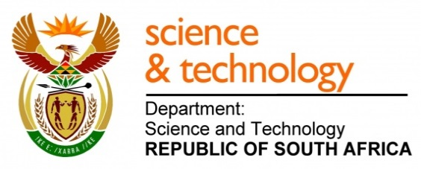
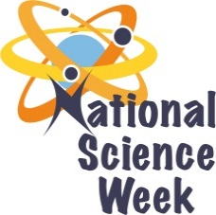
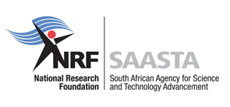
NATIONAL SCIENCE WEEK 2017

ORGANISATION NAME: |  |  |  | MATHS & SCIENCE LEADERSHIP ACADEMY NPC
CONNECT WITH US ONLINE |  |  | Twitter: |  | >
 |  |  | Facebook: |  | >
 |  |  | Website: |  | >
DATE OF ACTIVITY | DISTRICT WHERE ACTIVITY BEING HELD | VENUE WHERE ACTIVITY IS TAKING PLACE | ACTIVITIES  (Provide a short description of the activity) |  |  | TARGET AUDIENCE | TIMESLOT | CONTACT PERSON  EMAIL ADDRESS  PHONE NUMBER | BOOKING REQUIRED  (YES OR NO)
07, 08, 10 & 11 August | Francis Baard | MSLA Campus | Grade 6 STEM workshops will include the following activities:  - pulsating drumming session  - Maths Tourist  - SET Career presentations  - Science Tourism in the Northern Cape |  |  | 480 Grade 6 learners and 32 teachers from 16 targeted schools in Kimberley. | 2 workshops per day from 08:00 – 13:00.  Each workshop will run for 2hours 40 minutes. | Anne Maclean  anne@msla.org.za  053-8325047 | No – invited schools only
11 August | Francis Baard | MSLA Campus | Kids teaching Parents Workshop will include:  - What is National Science Week all about & the importance of STEMI  - IYT 2017 & the importance of science tourism  - Fun with maths: Can Parents make the CASIO calculator count? Problems relating to a MATHEMATICS TOURIST  - All about the Bloodhound SSC – example of SCIENCE TOURISM in the Northern Cape |  |  | 60 parents of MSLA learners | 17:00 – 20:00 | Anne Maclean  anne@msla.org.za  053-8325047 | No-parents by invitation only
10 August | Francis Baard | Radio Teemaneng | Girls Radio Talk Show  The MSLA GIRL learners will address the following topics:  - What NSW is all about  - Motivating the youth of the Northern Cape Province, especially GIRLS, to take maths & science at school and to work hard in these subjects which are the key to the future  - Inspiring the youth of the province, especially GIRLS, to have a dream in life and to take up SET careers in order to radically transform the economy of South Africa  - Highlighting the IYT and the importance of SCIENCE TOURISM in the Northern Cape |  |  | Radio Teemaneng listeners | 17:00 – 17:30  To be confirmed | Anne Maclean  anne@msla.org.za  053-8325047 | N/A
12 August | Francis Baard | Diamond Pavilion | Science Tourism Exhibition  The focus will be on the theme: SCIENCE TOURISM.  Special inclusion will be made of the BLOODHOUND SSC Project, a global Engineering Adventure, using a 1000 mph World Land Speed Record attempt to inspire the next generation about science, technology, engineering and mathematics. |  |  | Diamond Pavilion shoppers | 08:00 – 15:00 | Anne Maclean  anne@msla.org.za  053-8325047 | N/A

