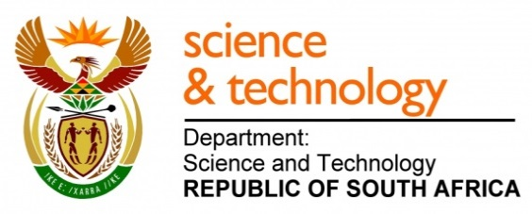
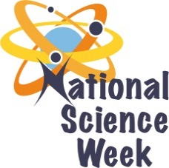
NATIONAL SCIENCE WEEK 2017

ORGANISATION NAME: |  |  |  | >Wordwise Media
CONNECT WITH US ONLINE |  |  | Twitter: |  | >
 |  |  | Facebook: |  | >
 |  |  | Website: |  | >
DATE OF ACTIVITY | DISTRICT WHERE ACTIVITY BEING HELD | VENUE WHERE ACTIVITY IS TAKING PLACE | ACTIVITIES  (Provide a short description of the activity) |  |  | TARGET AUDIENCE | TIMESLOT | CONTACT PERSON  EMAIL ADDRESS  PHONE NUMBER | BOOKING REQUIRED  (YES OR NO)
5-12 Aug | Francis Baard Municipality | Diamond pavilion  Kimberley | Sink, splash and swim quiz |  |  | Public | Every 30 minutes  Between 09:00 and 16:00 | Lizelle de Bruin  lizelle@wwmedia.co.za  0219763366 | no
5-12 Aug | Mangaung Metropolitan Municipality | Mimosa Mall  Bloemfontein | Sink, splash and swim quiz |  |  | Public | Every 30 minutes  Between 09:00 and 16:00 | Lizelle de Bruin  lizelle@wwmedia.co.za  0219763366 | no
5-12 Aug | Buffalo City Metropolitan Municipality | Hemmingway Mall  East London | Sink, splash and swim quiz |  |  | Public | Every 30 minutes  Between 09:00 and 16:00 | Lizelle de Bruin  lizelle@wwmedia.co.za  0219763366 | no

