**NATIONAL SCIENCE WEEK2017**

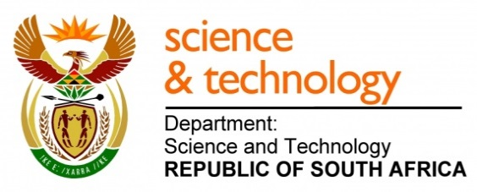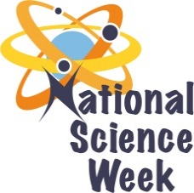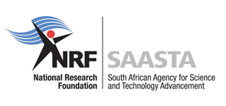

|  |  |  |  |  |  |  |  |  |  |
| --- | --- | --- | --- | --- | --- | --- | --- | --- | --- |
| **ORGANISATION NAME:** | | | | **>SLEG CONSULTING** | | | | | |
| **CONNECT WITH US ONLINE** | | | **Twitter:** | | **>@bushymoabelo** | | | | |
| **Facebook:** | | **>Eding International Science Festival** | | | | |
| **Website:** | | **>** | | | | |
| **DATE OF ACTIVITY** | **DISTRICT WHERE ACTIVITY BEING HELD** | **VENUE WHERE ACTIVITY IS TAKING PLACE** | **ACTIVITIES**  **(Provide a short description of the activity)** | | | **TARGET AUDIENCE** | **TIMESLOT** | **CONTACT PERSON**  **EMAIL ADDRESS**  **PHONE NUMBER** | **BOOKING REQUIRED**  **(YES OR NO)** |
| 7-11 August | Bojanala | Phokeng/Moruleng | **Touring Science of Indigenous Knowledge System, a public lecture.**  The Lecture involves a pictorial, video and data presented at the Halls. It evokes medicinal knowledge, use and preservation; shows pictures and video compiled by SLEG of interviews with herbalists talking to the profession and its practice. The lecture gives names of herbs in their indigenous languages. | | | **Learners, public and students in FETs** | 10h00-10h45 | Bushy Moabelo  [slegconsulting@gmail.com](mailto:slegconsulting@gmail.com)  072 8711 897 | NO |
| 5,6 & 12 August | Bojanala | Moruleng/Phokeng | **Arts/Culture touring Science through Innovative fusing of science content into Pule-Nyana, performance, Mmapadi, Dinaka, HipHop and AfroSoul.** | | | **Learners, public and students in FETs** | 10h00am-4h00pm | Bushy Moabelo  [slegconsulting@gmail.com](mailto:slegconsulting@gmail.com)  072 8711 897 | NO |
| 7-11 August | Bojanala | Phokeng/Moruleng | **Playing Mathematics, Biodiversity, Astronomy Quizzes and Optical Illusion**   * **Math Quiz** * **Biodiversity Quiz** * **Astro Quiz** * **Optical Illusion Quizzes** | | | **Learners, public and students in FETs** | 11h00am-12h30pm | Bushy Moabelo  [slegconsulting@gmail.com](mailto:slegconsulting@gmail.com)  072 8711 897 | NO |
| **7-11 August** | Bojanala | Rustenburg CBD-Taxi ranks, Hospital, Mining Areas, Schools | **Interactive Hands-on WOW Activities**   * **Technology from simple materials** * **Science into Toys** * **Physics & Chemistry Magic Shows (Vacuum demonstrations with 5 different size syringes and Jars with balloons, Eating away Styrofoam cups with acetone,** | | | **Learners, public and students in FETs** | 11h00am-12h30pm | Bushy Moabelo  [slegconsulting@gmail.com](mailto:slegconsulting@gmail.com)  072 8711 897 | NO |
| 7-11 August | Bojanala | Phokeng/Moruleng | **PUBLIC LECTURES**  **ON CAREERS IN STEMI: Community hall bound PowerPoint/Multimedia lecture series**  **SA INVENTION highlighting topical subjects in Waterless Bath-and SA discovery, Astronomy-SKA, Bloodhound, Gravitational Field Sounds and the New Planet discovery.**  **Touring the STEMI career through video based presentation of actual STEMI practitioners at work shown to FET students, learners and educators.** | | | **Learners, public and students in FETs** | 12h30-13h30  14h30-15h30 | Bushy Moabelo  [slegconsulting@gmail.com](mailto:slegconsulting@gmail.com)  072 8711 897 | No |
|  |  |  |  | | |  |  |  |  |
|  |  |  |  | | |  |  |  |  |
|  |  |  |  | | |  |  |  |  |