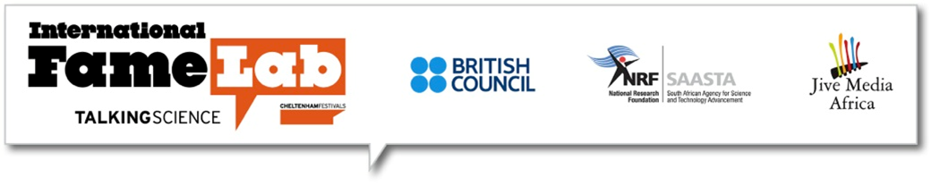
Who is going to be the next South African ‘Pop Idol of Science’?
On 4 May 2016, at the Going Global Conference at the Cape Town International Convention Centre, the heat will be on, when the 10 finalists compete for the coveted title, ‘South Africa’s Pop Idol of Science’.
The winner of the FameLab South Africa competition will represent the country on a world stage at The Times Cheltenham Science Festival in the United Kingdom on 8 and 9 June 2016, competing against their peers worldwide.
The 10 finalists were selected from 19 top young science communicators across the country at the FameLab South Africa semi-finals that took place at Sci-Bono Discovery Centre on Saturday 12 March.
“The FameLab semi-finalists were brilliant and they delivered top class talks. Our judges had a tough time in selecting the 10 finalists,” said Science Communications Manager at the South African Agency for Science and Technology Advancement, Mr Michael Ellis.
“At SAASTA our focus is not only on the ultimate National FameLab winner but we believe that all of the participants benefit greatly from the competition. They gain valuable science communication skills which they will use throughout their scientific careers,” he added.
It’s not just about fame however; this comes at a time when the importance of public engagement and discourse in science and technology is better recognised, as evidenced by the Department of Science and Technology’s Science Engagement Strategy. Science should serve society and can only do so if the public is able to engage with it. Unfortunately, scientific concepts and findings are not always communicated effectively to the public. This is what FameLab strives to address.
Through FameLab, diverse young scientists have been provided with the opportunity to improve their communications skills or discover their talent for communicating science, and engage with public audiences on varied science topics.
FameLab Format
The format of the FameLab competition requires participants to present a scientific topic or concept to a panel of expert judges in a time of no more than three minutes. Talks are judged on content, clarity and charisma. The challenge is that talks should be accurate and informative but also entertaining and original, all while making sure the public audience understands.
FameLab is an international competition and training programme designed to inspire, motivate and develop young scientists and engineers to actively engage with the public. With over 30 participating countries, worldwide, it has been dubbed the ‘Pop Idols of Science’!
Watch the 10 finalists’ semi-finals presentations
http://www.saasta.ac.za/competitions/famelab/who-will-be-the-2016-sa-pop-idol-of-science/
The 10 passionate young scientists selected to participate in the national finals are:

Tashnica Sylvester Molecular Biology and Human Genetics – Stellenbosch University
Margaret Siyawamwaya Pharmaceutical Sciences - University of Witwatersrand
Nozipho Gumbi Nanotechnology and Water Sustainability (NanoWS) - UNISA
Savannah Nuwagaba Biomathematics - Stellenbosch University
Tendai Samkange Pharmaceutical Sciences - University of the Western Cape
Claude Moshobane South African National Biodiversity Institute (SANBI) and the Centre for Invasion Biology - Stellenbosch University
Charles O’Donoghue Department of Chemistry - Rhodes University
Wandisile Sixhoto Agricultural Extension - University of Fort Hare
Robert Schlegel Department of Marine Sciences - University of the Western Cape
Marli Louw Institute for Wine Biotechnology – Stellenbosch University

FameLab in South Africa is made possible by a partnership between the British Council, the South African Agency for Science and Technology Advancement and Jive Media Africa.
/END

EDITORS’ NOTES

About the British Council:
The British Council is the UK’s international organisation for educational opportunities and cultural relations. We create international opportunities for the people of the UK and other countries and build trust between them worldwide.
For more information, please visit: http://www.britishcouncil.org.za/. You can also keep in touch with the British Council through https://twitter.com/zaBritish

About Jive Media Africa:
Jive Media Africa creates innovative, cutting edge communications; grabbing attention and conveying crucial messages in accessible ways.
An award-winning multi-media company, Jive Media Africa produces media strategies and products that challenge and inform, making a difference in the areas of Science and Technology (Jive Science), Biodiversity Conservation (Jive Earth), Children in the context of HIV/ AIDS (Jive Children) and Human Rights (Jive People).
Jive Media Africa strategises the best combination of media for the message, and importantly, for the target audience.
For more information, please visit http://jivemedia.co.za/. You can also follow them on Facebook: https://www.facebook.com/JiveMediaAfrica

About SAASTA:
The South Africa Agency for Science and Technology Advancement (SAASTA) is a business unit of the National Research Foundation (NRF) with the mandate to advance public awareness, appreciation and engagement of science, engineering, innovation and technology in South Africa.
SAASTA’s contribution to the NRF’s vision is to grow the pool of quality learners today who will become the scientists and innovators of tomorrow.
All science engagement programmes within the NRF reside under three key strategic areas that combine to form an integrated and seamless approach.
Through education we build up the supply of tomorrow’s scientists and innovators.
Through communication we celebrate South African achievements in science and technology and build the public’s appreciation of the benefits of science.
By growing the awareness of science through exploration, exhibitions and actual experience, we instil in people an enthusiasm about the wonder and application of the subject, while encouraging greater public engagement in SET issues.
By taking overall ownership of science advancement initiatives within the NRF and on a countrywide scale, SAASTA is responding to an organisational as well as national imperative.

Contacts:

Anisa Khan, British Council: Newton Fund and Higher Education Programme Manager

Tel: 011 560 9322 Cell: 082 783 8430 Email: Anisa.Khan@britishcouncil.org

Shavaughn Haack, British Council: Communications Manager

Tel: 011 560 9348 Cell: 082 821 8967 Email: Shavaughn.Haack@britishcouncil.org
Robert Inglis, Jive Media Africa Director
Tel: 033 342 9380/2 Cell: 084 357 7333 Email: robert@jivemedia.co.za
Joanne Riley, SAASTA, Science Editor: Science Communication
Tel: 012 392 934 9 Email: joanne@saasta.ac.za

