**SANYSO 2015 Physics - Memorandum**

*1 D*

*2 B*

*3 C*

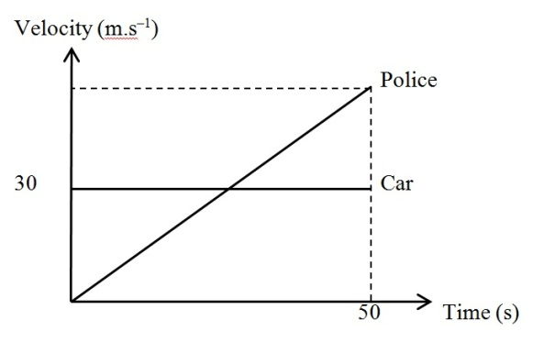*4 D*

*5 D*

*For the police to catch the car, the distance*

*travelled by police must equal to distance travelled by car since beginning of the chase.*

*½ x 50 x vP = 30 x 50 so vP  = 60 m.s –1*

*6 A*

*From the graph the acceleration of the police car is:*

**

*7 A*

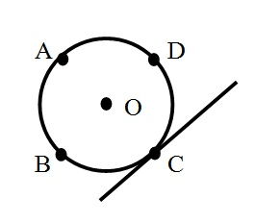*8 C*

*Point C is the point of contact, and since the hoop is rolling down the slope, and not sliding, the point of contact has speed = 0*

*9 D*

*The centre of mass of both the bob and the ring are in their centre. So by placing the ring on top of the bob, effectively change the position of the centre of mass upwards, thereby shortening the length of the pendulum.*

*10 C*

*Think carefully – the question is asking about speeding up – so one is only talking of magnitudes!! So from 0 m.s–1to – v m.s–1 is the same as going from 0 m.s–1to v m.s–1! ie it’s speeding up!*

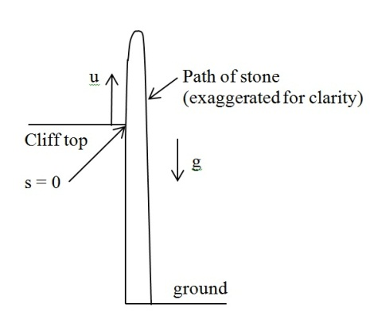*11 B*

*From the question we know that:*

*u = 29.4 m.s–1*

*s = – 78.4 m, and*

*a = –g = –9.8 m.s–2*

*Then using s = ut + ½ at2 we get:*

*–78.4 = 29.4 + ½( –9.8)t or –78.4 = 29.4 – 4.9t*

*So (t + 2)(t – 8)= 0 which means that t = –2 or 8 seconds.*

*12 B*

*Change of kinetic energy, ∆EK = ½ m(v2 – u2) = 500 x 75 = 37 500 J*

*13 A*

*Power = rate of doing work, ie.* .

*From the question given we also have that F = kv. Substituting for F we get:*

 *so v = 12.2 m.s –1*

*14 B*

*Work done = F x dist = ∆EK ie. Fs = ½ mv2*

*So 40F = 400 x 64 or F = 640 N. As the vehicle is slowing down the force is opposing the motion of the vehicle.*

*15 D*

*Impulse = change of mtm ie. I = ∆(mv) = m∆v = m(v – (– u)) = m(v + u). Substituting:*

*11 = 0.42(v + 10) so 0.42v = 11 – 4.2 and therefore v = 16.2 m.s–1*

*16 C*

*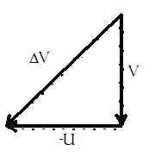 The only relevant information needed to answer this is the speed and the change of direction!*

*Change in velocity is vF – vI. But this is a vector equation!*



*17 C*

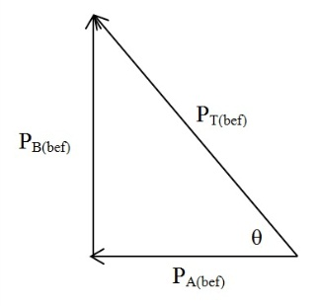 *Before collision:*

*mtm car A = PA(bef) = mA vA = 500 x 20 = 1 x 104 Ns W*

*mtm car B = PB(bef) = mBvB = 650 x 25 = 1.625 x 104 Ns N*

*Total mtm = PT(bef) = PA(bef) + PB(bef)*

*PT(bef) =  = 1.908 x 104 Ns*

*Now *

*So the final mtm is 1.908 x 104 Ns N31.6oW and since mtm before = mtm after this is* *the answer as well.*

*18 A*

*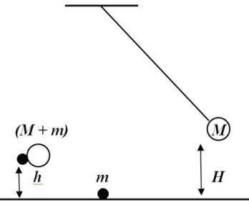 Normally one would think that h = H, but during the collision the pendulum loses some energy!*

*So the initial speed  just before impact.*

*So PB = Mu = and PA = v(m + M) now PA = PB*

ie.  so 

So EK after = EP after, ie. ½(M +m)v2 = (M + m)gh but 

So  simply 

Since EP = EK we get:  giving 

*19 C*

*At the instant when the pendulum collides with the nail, m has a velocity . The angular momentum of the mass with respect to the point at which the nail locates is conserved during the collision. Then the velocity of the mass**is still **at the instant after the collision and the motion thereafter is such that the mass**is constrained to rotate around the nail. Under the critical condition that the mass can just swing completely round in a circle, the gravitational force is equal to the centripetal force when the mass**is at the top of the circle. Let the velocity of the mass at this instant be v1, and we have*

* then from the energy equation we get:*



*20 A*

*Mtm P = mv and kinetic energy E = ½ mv2*

*So P2 = m2v2 ie. *

*21 B*

*You are doing work against friction, not against gravity: ie. you are not changing the potential energy of the car.*

*22 B*

*The flight time of a projectile is given by. For this question for both the projectiles, vo and g are constant, therefore  or .*

*So the projectile fired at 20o will take shorter time than projectile fired at 70o.*

*Similarly the range *

*Sin 40 = sin 140, so R is the same for both.*

*23 C*

*We have the height h at two different times, t and T, taking up as + and using s =ut + ½ gt2 we get:*

*h = ut – ½ gt2 and H = uT – ½ gT2 equating these two gives:*

*ut – ½ gt2 = uT – ½ gT2 and simplifying gives*

*u(t – T) = ½ g(t2 – T2) or u(t – T) = ½ g(t – T)(t + T) or u = ½ g(t + T)*

*24 C*

*36 km/h = 10 m.s–1 so 30km/h = m.s–1*

*Centripetal acceleration so the centripetal force*

*25 A*

*The frictional force on the child is μmg and the centripetal force is mRω2, so the critical radius occurs when these two forces are equal. ie rearranging this gives:*



*26 D*

*Using Newton’s law of Universal Gravitation,  we have for the astronaut on Earth:*

* and for the astronaut on the Moon then rearranging both we get*

*and the equating these from which we get*

**

*27 B*

*Let* ***g*** *and* ***g'*** *be the gravitational accelerations at the pole and at the equator respectively and consider a body of mass* ***m*** *on the surface of the planet, which* ***has*** *a mass M. At the pole,*

**

*At the equator, we have*

**

*If we define gravitational potential energy with respect to a point at infinity from the planet, the body will have potential energy:*

**

*Note that the negative sign in front of the gravitational force takes account of its attractiveness. The body at the pole then has total energy;*

**

*For it to escape from the planet, its total energy must be at least equal to the minimum energy of a body at infinity, i.e. zero. Hence the escape velocity ve is given by:*

**

*28 A*

*Density = and since the volume of a sphere V =*

*So and let M= mass of the Large sphere, and m the mass of the small sphere, we have:*

*29 D*

*Assume the water flows through the pipe continuously. Water flows from the larger diameter to the smaller diameter pipe: from one of diameter D to one of diameter D/2. This means the area of the smaller pipe is ¼ the area of the larger pipe and therefore the volume of water that moves from the larger to the smaller pipe is the same, so its length should be 4X longer. This length of water must therefore move 4X faster, or 16 m.s–1*

*30 C*

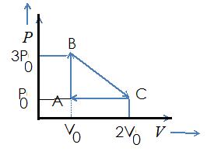

*31 A*

*32 A*

*Work done = area of a PV curve ie *

*33 C*

*34 B*

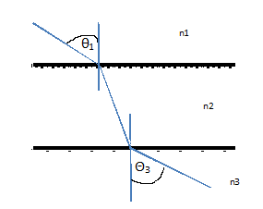*35 A*

*36 B*

*The angle of refraction inside the glass is:*

**

*Then we use θ2 as the angle of incidence on to the boundary between the glass and the air on the other side, hence the angle of refraction in the air is:*

**

*37*  ***A***

*In static electricity, the only charges that move around are electrons. Hence if a neutral object becomes negatively charged, means that it has gained electrons. In the question it is assumed that both cloth and rod are neutral initially and that the rod ends up negatively charged which means that electrons were transferred from the cloth to the rod.*

*38 D*

*Using Coulomb’s Law: so initially *

*After touching the total charge is 6 μC and each conductor will carry 3 μC of charge.*

*So now is *

*So F’ = F/8*

*39 D*

*Let the force between q1 and q2 be FX, and that between q2 and q3 FY. Inspection shows that FX pushes q2 to the right (repulsive force), and FY pulls FY to the right (attractive force). This means that the resultant force FR on q2 is FR = FX + FY*

*and  then *

*40**D*

*The Volt can be defined as the work done per unit charge, or V = W/q. It should also be remembered that work and energy are the same so V = E/q. Now q = e (electron charge) and*

*E = ½ mu2. So:*

**

*41**D*

*Effectively these resistors are in parallel. Hence their total resistance R is:*

*1/R = 1/R1 + 1/R2 + 1/R3 = 1/3 + 1/3 +1/3 = 1. So R =1Ω*

*42 B*

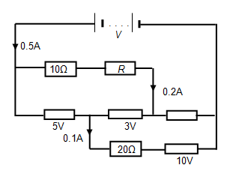

*Current through R =0.2A and the PD across the 10Ω resistor and R is 8V. PD acros the 10Ω resistor = 2 V, so the PD across R = 6 V and *

*43 C*

*Current through the 20Ω resistor is 0.1A so PD across it = 2 V.*

*Thus the total PD =5V + 2V + 10 V = 17 V*

*44 B*

*The capacitive resistance is determined by *

*So *

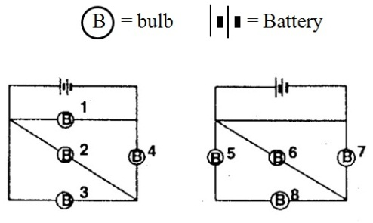

*45 C*

*In the circuit containing bulbs 5, 6, 7 and 8 all the bulbs are shorted out, and so none are on. So any answer containing 5, 6, 7 or 8 cannot be right, leaving only answer C.*

*Alternatively redraw the left hand circuit so that the wire with bulb 2 is parallel to the wires of bulb 1 and 3*

*46 A*

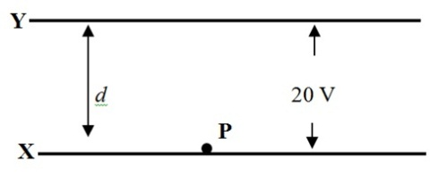 *PD, in volts, is equal to the work per unit charge,*

*so: *

*to get: *

*47 B*

*As is shown in the calculation above, the speed is independent of the distance between the plates, so the speed remains at u*

*48 A*

*49 C*

*If m is the mass of proton, then the masses of deuteron (one proton and one neutron) and alpha particle (two protons and two neutrons) are 2m and 4m respectively.*

**

*So *

*50 C*

*Distance between detectors in rest frame of particles *

*Time taken in rest frame of particles *

*Time taken for the intensity to decrease to a ¼ = two half-lives *

*ie. One half-life = 8.5 x 10–9 s*

|  |  |  |  |  |  |  |  |  |  |
| --- | --- | --- | --- | --- | --- | --- | --- | --- | --- |
| ***Answers for SANYSO Physics 2015*** | | | | | | | | | |
| *1 D* | *2 B* | *3 C* | *4 D* | *5 D* | *6 A* | *7 A* | *8 C* | *9 D* | *10 C* |
| *11 B* | *12 B* | *13 A* | *14 B* | *15 D* | *16 C* | *17 C* | *18 A* | *19 C* | *20 A* |
| *21 B* | *22 B* | *23 C* | *24 C* | *25 A* | *26 D* | *27 B* | *28 A* | *29 D* | *30 C* |
| *31 A* | *32 A* | *33 C* | *34 B* | *35 A* | *36 B* | *37 A* | *38 D* | *39 D* | *40 D* |
| *41 D* | *42 B* | *43 C* | *44 B* | *45 C* | *46 A* | *47 B* | *48 A* | *49 C* | *50 C* |

***Distribution***

*A = 13 B = 12 C = 14 D = 11*